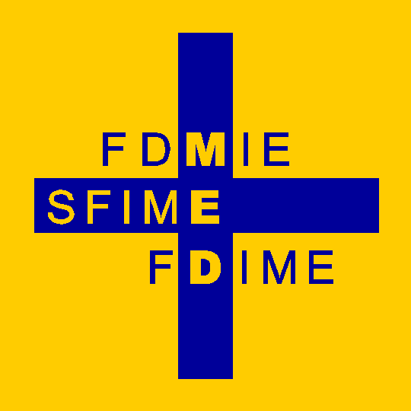 | Fondation pour le Développement de la Médecine Interne en Europe  Stiftung für die Förderung der Inneren Medizin in Europa  Foundation for the Development of Internal Medicine in Europe  FDIME Management Committee  President: Prof Daniel Sereni sereni.daniel@gmail.com  Vice-President: Prof Ramon Pujol Farriols ramon.pujolf@gmail.com  Secretary General: Dr Jan Willem Elte jwfelte@gmail.com  Treasurer: Dr Imad Hatem zephyr@swissonline.ch
For the attention of:
EFIM National Societies of Internal Medicine

Dear Friends & Colleagues

FDIME Announces the 19th FDIME-EFIM Clinical Research Course, Paris
Seminar dates: 09-11 October 2024 (residents arrive on 08 October 2024).

This important educational resource is available again for EFIM Young Internists who are interested to advance their Clinical Research skills. Sponsorship for the Seminar is provided by the Foundation for the Development of Internal Medicine in Europe (FDIME).

We welcome applications from young internists/researchers under the age of 35 years with a good knowledge of English, being currently or recently involved in a clinical research activity.

Please forward the enclosed information to potential candidates in your department, and/or announce the Seminar on your Society websites or via newsletter.

Places are limited and bursaries are available for up to 15 residents (covering travel and hotel accommodation for a 3 night stay in Paris). Residents will arrive on 8 October.

Online application is now open at: apply@fdime.org

The closing date is: 15 August 2024

The Clinical Research Selection Committee will assess all applications and places will be awarded to the 15 most suitable candidates. Successful applicants will be notified before the end of September.

Thank you for helping to raise awareness of the Seminar through your personal contacts with Young Internists and via your National Society websites. Text for websites is enclosed. For any other requirements, please contact:sjeanbart@yahoo.com
With best regards
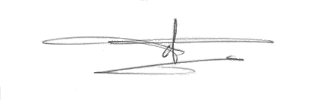
Pr. Daniel Sereni
FDIME President
Chairman, FDIME-EFIM Clinical Research Seminar
Email: sereni.daniel@gmail.com

Encs: 1) Announcement Clinical Research Seminar
2) Application form (online application is preferred and available as indicated)
3) Clinical Research Seminar Schedule

